RPT COMPOSITION OF PROMOTION AND TENURE DOSSIERS
The RPT Template has the following sections (A-G). Upload documents into each section as described below, following the naming conventions as indicated:
- Candidate Information
Required: S&T Prom-Ten Candidate Information Form
- Candidate’s CV
Required: Upload your CV. FirstInitialLastName_CV
- Research, Scholarship and Creative Activities
Required Materials
- Research Statement -- Self-Assessment. FirstInitialLastName_ResearchStatement
- Form A: Scholarly Work Published since date of initial employment at S&T or since last promotion. FirstInitialLastName_Publications
- OSP Grants and Expenditures. Upload the file sent to you by Faculty Affairs. Sponsored Programs runs this report at the request of Faculty Affairs and you will have the chance to review before uploading. FirstInitialLastName_OSP.
- Form B: Graduate Faculty Related Activities Summary. FirstInitialLastName_GradFac
- List of Internal Grants (fillable form in RPT)
- Teaching
Required Materials
- Teaching Statement – Self Assessment. FirstInitialLastName_TeachingStatement
- Form C: Summary of SET. FirstInitialLastName_SET
Optional Materials
- Student Evaluation Comments. FirstInitialLastName_StudEval
- Student Letters of Support. FirstInitialLastName_StudentLetters
- Peer Evaluation Reviews. FirstInitialLastName_PeerEval
- Other Teaching Assessments. FirstInitialLastName_TeachAssess
- Service
Required Materials
- Service Statement – Self Assessment. FirstInitialLastName_ServiceStatement
- Verification of accuracy
- Open RPT to attest that all submitted information is accurate
- Supplementary Information
Required Materials
- Publications: links to up to five publications. FirstInitialLastName_Publications
Optional Materials
- Letters of Support. FirstInitialLastName_LettersofSupport
- Other supplemental information. FirstInitialLastName_OtherSuppInfo

*******************************
Instructions: Please refer to the guidance below when completing each section of your dossier in RPT. Reach out to Faculty Affairs at with any questions.
- Candidate Information
Answer each question carefully. Evaluators will refer to these answers when reviewing your application.
B. Candidate's Curriculum Vitae (CV)
The CV should represent the candidate's experience and contributions as accurately and completely as possible. Incomplete or potentially misleading information — even by omission — can weaken an otherwise strong case, as evaluators will consider both what is included and what is left out.
While no single format is required, the CV must include the following sections at minimum:
- Name and Current Academic Address
- Academic Background
List all degrees earned, including the department, institution, and dates of attendance. Include the title(s) of any thesis or dissertation and the name(s) of the advisor(s).
- Work Experience
Provide a complete employment history, including position titles, employer or industry, and dates of employment.
- Scholarly Contributions
This section receives careful scrutiny from evaluators and should be organized with precision.
Organization: Group contributions into clearly labeled categories: books, refereed journal articles, refereed conference papers, other publications, abstracted talks, invited lectures, and other scholarly contributions. List refereed conference papers separately from refereed archival (journal) papers.
Co-authored work: For all co-authored works, indicate the candidate's degree and nature of contribution.
Required citation information: All publications, refereed or otherwise, should include: author(s), title, journal name, volume, page numbers, and publication date. For book chapters, also include the editor's name, publisher, and publisher's location.
Each entry should contain enough information for the work to be easily located.
Presentations and oral contributions: Include the date, location, and sponsoring organization, with enough detail for an evaluator to verify the contribution.
Creative works: Exhibits, performances, or showings should be described in sufficient detail for evaluators to assess the scholarly or creative achievement.
- Research Grants and Contracts
List all grants and contracts received. For each, include: project title, funding agency, total dollar value, period of expenditure, and the candidate's specific role. As with co-authored publications, clearly describe the division of labor among investigators.
- Teaching Experience
List teaching positions by institution, including dates of service, general subject areas, and the academic level of courses taught. Detailed descriptions should be omitted from the CV and submitted as supplementary material if needed.
- Department and University Service
List committee memberships and special responsibilities, including dates of service.
- Professional Service and Society Memberships
List memberships in professional organizations, including any offices held and dates of service.
- Additional Items
Other relevant information may be included at the candidate's discretion. Any addition should be evaluated for whether it strengthens the overall picture of a faculty member engaged in scholarship, teaching, and service. Candidates are strongly encouraged to review their CV with their department chair and other mentors before submission.
C. Research, Scholarship and other Creative Activities
Research Statement – Self Assessment. This section allows candidates to provide a substantive, critical self-assessment of their scholarly and research accomplishments. Rather than cataloguing all contributions exhaustively, candidates should focus on a representative selection of their most significant work — discussing its significance, coherence, impact, and trajectory.
The assessment should also address the following:
- Research philosophy. Candidates are encouraged to articulate the intellectual framework guiding their research.
- Innovative contributions. Candidates should identify what is original or distinctive about their work.
- Broader research context. Candidates should situate their work within its broader research context. When relevant, candidates may discuss how shifts in funding priorities or changes in external support have shaped their research and demonstrate their initiative, adaptability, and sustained commitment to scholarly productivity.
- Future directions. Candidates should outline their plans for continued scholarly activity.
The ability to evaluate one's own work thoughtfully and accurately — recognizing its strengths, limitations, and place within the field — is itself a mark of professional judgment and intellectual leadership.
Along with the Research Statement—Self Assessment, candidates must complete and upload Form A, which lists published works. Note: Actual publications are not included in the dossier, but you may include hyperlinks to up to five publications in a Supplemental Dossier pdf file (Section H; see instructions below). Section C of the dossier also includes a completed sponsored research activities report since last promotion and a report from the Vice Chancellor for Research and Innovation regarding research expenditures. These documents C are generated by the Office of Sponsored Programs and are sent to the candidate from the Office of Faculty Affairs to be reviewed before being uploaded into RPT.
If choosing this option, please include the title, name of the PI and CO-PI, percent of effort, name of the funding agency, and total direct cost. The candidate should also complete and upload Form B (Graduate Activities), even if there are no graduate activities to report. Finally, the candidate must enter information about any internal grants received; a fillable form opens up in RPT. If no internal grants were received, select no for the first question.
RPT Actions for Section C:
Upload the following:
- Research Statement -- Self-assessment (required)
- Form A: Scholarly Work Published (required)
- OSP Grants and Expenditures (required)
- Form B: Graduate Faculty Related Activities Summary (required)
- Internal Grants (optional; a fillable form opens up in RPT)
D. Teaching
Teaching Statement – Self Assessment: This section allows candidates to present a rich, multidimensional picture of their teaching effectiveness. Student evaluation scores (SETs) are one data point among many, and candidates are encouraged to draw on a wide range of evidence to illustrate the quality and impact of their teaching.
The self-assessment should include a discussion of teaching philosophy: the values, principles, and approaches that guide the candidate’s teaching. This document might also include reflections on teaching techniques, methods, and goals; a discussion of how one’s teaching has evolved over time; and/or descriptions of challenges encountered and adjustments made in response. Candidates should discuss their SET scores in context rather than reporting them in isolation. This includes interpreting trends over time, explaining differences across courses or course levels, and describing how student feedback has informed adjustments to their teaching. Candidates should highlight any new courses designed or existing courses that have been substantially revised. Candidates should include evidence of teaching effectiveness, which might include student feedback, evidence of student success, curricular and pedagogical contributions (i.e., development of new instructional materials, adoption of innovative or evidence-based teaching methods, integration of research or real-world problems into coursework, publications or presentations in education journals or pedagogy conferences, grants received to support teaching innovation or curriculum development); evidence of student engagement and mentorship, and/or recognition and external validation (i.e., teaching awards/nominations, invitations to share teaching expertise at workshops or conferences, adoptions of course materials or approaches by others).
Summary of SET (Form C): Include information for each course taught or team-taught since S&T appointment (for tenure candidates) or since the last promotion (for a maximum of five years).
Student Evaluation Comments (optional): Students’ written comments from the SET may be included for courses taught over the most recent five years, but either all or none of the comments shall be included with the following exception: Comments that are discriminatory may be redacted from the data set. In consultation with department chairs, individual faculty members can remove irrelevant and unfair characterizations. If an instructor and the department chair disagree about a redaction(s), the matter will be arbitrated by the Dean’s office. If resolution cannot be reached at the Dean level, the matter will be arbitrated by the Provost’s Office. Examples of discriminatory comments that may be removed include:
- Comments that reference race, gender, ethnicity, etc.
- Comments that reference instructor appearance (e.g., clothing, hair, physical features, etc.)
- Comments using profane, offensive, hostile or otherwise inappropriate language
- Comments that are racist, sexist, homophobic, etc.
Student comments are to be saved as one document and organized with the most recent course taught first to the oldest course taught last.
Student Letters of Support (optional) may be included only if they are solicited by a third party under controlled conditions. Up to five letters can be included, saved as a single document. Seek assistance from your department chair if you intend to include student letters of support in this section.
Peer Evaluation Reviews (optional): Peer reviews may be conducted by colleagues within or outside your department, or by the Peer Evaluation of Teaching (PET) program. Peer teaching evaluations typically involve class visit(s), reviews of teaching materials, and often conversations between the reviewer and the candidate. Peer reviews are valuable additions to the dossiers of both assistant and associate professors going up for promotion. For candidates for Professor, only include peer evaluation reviews conducted since the last promotion. Combine all peer evaluation reviews into a single document before uploading.
Other Teaching Assessments (optional): Any additional materials that demonstrate evidence of teaching effectiveness that do not easily fit into the other existing categories may be uploaded here as a single document.
RPT Actions for Section D:
Upload the following:
- Teaching Statement - Self Assessment (required)
- Form C: Summary of SET (required)
- Student Evaluation Comments (optional)
- Student Letters of Support (optional)
- Peer Evaluation Reviews (optional)
- Other Teaching Assessments not included elsewhere (optional)
E. Service
Service Statement – Self Assessment: This section should include a self-assessment of the candidate's service contributions at the department, college, university, system, and professional/disciplinary levels. The document should offer a reflective account of the level and quality of the candidate’s engagement in these service activities. Candidates should go beyond listing committee memberships and other activities to describe what they actually contributed. Where a candidate played a significant role — drafting a report, leading a working group, designing a survey, or otherwise shaping an outcome — that contribution should be documented and discussed in concrete terms.
RPT Actions for Section E:
Upload the following:
- Service Statement - Self Assessment (required)
F. Verification of Accuracy
Fill out the form in RPT to attest to the accuracy of all information of all non-confidential materials submitted in the dossier.
G. Supplementary Information
This section includes a required document with links to up to five publications. This section also accommodates letters of support and any other supplementary information not listed in any other category that would contribute to the evaluators’ assessment of the candidate.
RPT Actions for Section G:
Upload the following:
- One document with individual citations and hyperlinks connecting to up to five publications. (required)
- One document of letters of support from former advisors, collaborators, friends, and colleagues may be included in this section. The methods and conditions under which the letters of support were received shall be noted. All letters of support must indicate the title of the letter writer and the relationship of the letter writer to the candidate, i.e., colleague, faculty member, administrator, student, former student, etc. (optional)
- One document including any supplementary information not listed in any other category. (optional)

*********************************
Examples of the required forms that you will find in RPT are included below, for your information. When you are ready, download these forms from RPT, complete them, and upload them into the appropriate sections of the RPT dossier.

Form A
Scholarly Work Published Since First Employment at S&T or since last promotion for a maximum of five years
If there are publications with multiple authors, publication references should appear with authors listed in the order that they appear in the journal. Additional information about authors and contributors may also be indicated (e.g., undergraduate student contributor, graduate student contributor, etc.). At the end of the citations for each publication with multiple authors, describe the candidate’s contribution to the work in terms other than percent of effort.
Please complete each section listing the appropriate publications that have been accepted or published while the candidate (underline candidate’s name in each publication) has been at Missouri S&T or since last promotion for a maximum of five years. Use the following superscripts:
¹ - Corresponding Author
² - Student
³ - Former Advisor is Author
⁴ - Other Faculty/Post Docs
Status: Add (in press) at the end of the full citation.

Note: Do not include actual publications in this section; up to five publications can be included in a Supplemental Dossier saved as a single pdf file.

Refereed Journal Articles:
- Lennon², J.; McCartney¹, P.; Starr³, R.; and Harrison⁴, G. A Hard Day’s Night. Apple Recording Company, 1964.
- McCartney¹, P and Starr³, R. And now we are in our seventies. Unknown Recording Company, 2018 (in press).
Add numbers as needed

Books

1.

2.

Add numbers as needed
Conference Proceedings (Only list those presentations not accompanied by a conference publication):
1.
2.
3
Add numbers as needed

Book Chapters:
1.
2.

Add numbers as needed
Other Creative Activities
1.
2.

(Dates are for example)
OSP Grants and Expenditures
SPONSORED RESEARCH ACTIVITIES
LATEST FIVE YEAR SUMMARY

NAME:

College Committee:
DEPARTMENT:
GRANTS

FISCAL YEAR*

2015 | 2016 | 2017 | 2018 |  | 2019
Total Awarded ($) | $0 | $0 | $0
Shared Credit ($) | $0 | $0 | $0
Total Expended ($) | $0 | $0 | $0
Shared Credit ($) | $0 | $0 | $0

* Note: Fiscal year is defined as July 1 through June 30. For example, FY 2019 is from July 1, 2018
through June 30, 2019. Please note in the spaces below information for any grants obtained in
FY 2020 (awarded, shared credit and expended since July 1, 2019).

Awarded: ($): Shared Credit ($): Expended ($):

PROPOSALS

Fiscal Year 2020 Proposals**

Pending: Number: Dollar Amount: Shared Credit ($):

Accepted: Number: Dollar Amount: Shared Credit ($):

** If appropriate, on an attached sheet, report the number, dollar amount and shared credit for any pending or accepted proposals from earlier fiscal years that have not yet been awarded.

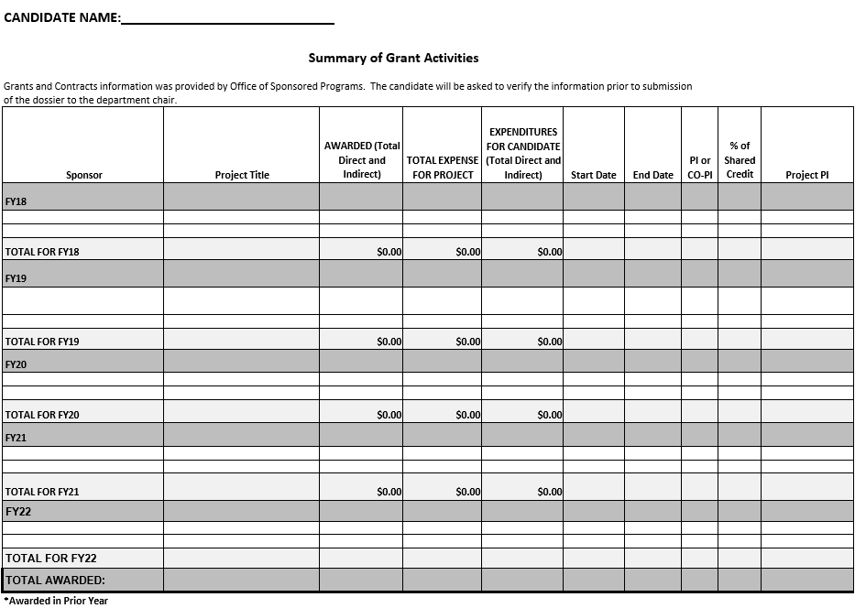

Form B

Graduate Faculty Related Activities Summary

NAME:
COLLEGE:_________________________________________________________________________________
DEPARTMENT: INITIAL MEMBERSHIP DATES:

General Faculty:
Graduate Faculty:
ACADEMIC YEAR*
Include information since your date of initial employment at S&T or since last promotion for a maximum of five years

Year | # M.S. students advised | # Ph.D. students advised | # M.S. degrees completed -advisor | # Ph.D. degrees completed -advisor | 5000 level* courses taught | SCH | 6000 level* course taught | SCH

* Do not list 5000, 5001, 5099, 6000, 6001 or 6099.

Form C
Summary of SET Table
From your first semester as an employee at S&T or since last promotion for a maximum of five years

Semester | Course Title | Credit Hours | Number of Students/  Number Evaluating | Overall SET Score

